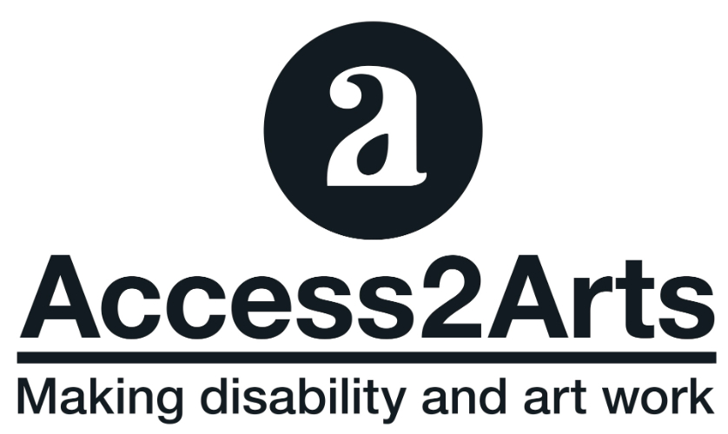

Staff Handbook
March 2016

Welcome…

This document aims to give Access2Arts staff, including casuals and contractors information about Access2Arts relationship with disability. Also provided is some general information general information on our Style Guide.

Please let us know if you’d like this information in another format.

FAQs

1 in 5 Australians have disability

88% hidden disability

Most Australians will spend 7-8 yrs. of their life with impairment
Disabled people are never just disabled people…we cross all demographics, race and gender.

Definition of Disability

Disability is the loss or limitation of opportunities to take part in the mainstream of the community on an equal level with others due to physical and social barriers. It has little to do with the individual’s condition or impairment.

Models of Disability

Models of Disability are tools for defining impairment and are a useful framework in which to gain an understanding of disability issues, and also the perspective held by those creating and applying the models.

Models are influenced by two fundamental philosophies. The first sees disabled people as dependent on society. The second perceives disabled people as citizens, which lead to choice, empowerment, human rights and equality.

There are many models of disability but the three most important to understand are:
.
The Charity Model depicts disabled people as victims of circumstance, deserving of pity. This and the Medical Model are probably the ones used most by non-disabled people to define and explain disability.

- Based on pity, tragedy and fear
- Institutional

The Medical Model holds that disability results from individual persons’ physical or mental limitations and is largely seen unconnected to the social or geographical environments.

- Deficit based
- Treatment based Need to be fixed

The Social Model views disability as a consequence of environmental, social and attitudinal barriers that prevent people with impairments from maximum participation in society.

Below is a short video on Social Model of Disability from Scope UK

For captioning: https://www.youtube.com/watch?v=0e24rfTZ2CQ

For more information on Models of Disability:: http://www.copower.org/leadership/models-of-disability

Another model you may hear about is the Affirmative Model of Disability
For more info on the Affirmative Model http://www.disabilityartsonline.org.uk/affirmative-model-of-disability

Our thinking about Disability

One of the most useful and progressive ways to help understand disability is to make a clear distinction between disability and impairment. In making this distinction, impairment and disability are defined in the following ways:

Impairment: a medical condition, illness or injury which will or is likely to impact on the way the body or mind works.

Disability: the limitation and exclusion of someone with an impairment to access opportunities and take part in society on an equal basis as the result of barriers.

Therefore, we do not use the word disability to mean impairment.

Discrimination and Barriers = Disability
People = Citizens
Access = Equal

Disability is re-defined as a social (not individual) issue. Furthermore,
barriers are not the inevitable outcome of impairment but are socially created through society not taking into consideration the requirements of people with impairments.
We are disabled by what society does to us: therefore, disability is like racism or sexism.
The framework that aids us understand the problems of ‘disability’ and helps us understand the best solutions to ‘disability’ is the Social Model of Disability.

Social Model of Disability

Discrimination/Barriers = Disability
People = Citizens
Access = Equality

- The problem is NOT the individual
- Involves everyone in identifying solutions
- Acknowledges people’s rights to full participation as citizens.

Access2Arts operates under The Social Model of Disability.
Therefore, under the ‘social' model, we acknowledge that it is the barriers created by society, which are ‘disabling' to an individual and that it is our collective responsibility to remove these barriers.

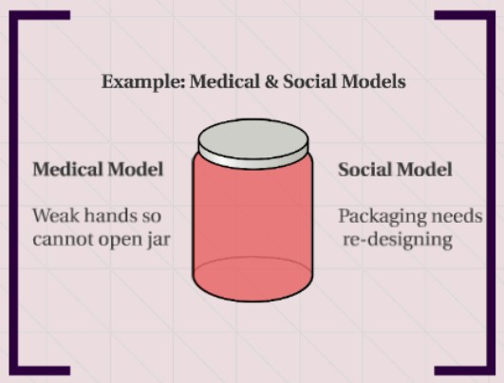

Image Alternative Text: Drawing of a jar. Text in image reads: Example of medical and Social Models. Medical Model – Weak hands so cannot open jar. Social Model – packaging needs re-designing

Deaf: Many people who use sign language as their first language identify as a cultural and linguistic minority, not as people with disability. We often use the term 'people with disability' to include Deaf people too, because the word 'disability' in the social model refers to barriers and because people who use Auslan (Australian Sign Language) tend to experience barriers lick discrimination or lack of access.

Access2Arts Guiding Principles:

The UN Convention on the Rights of People with Disability (UNCRPD):

Article 1 Purpose The aim of the Convention is to make sure that people with disability enjoy human rights, freedoms and respect like other people.
Article 30: Participation in cultural life, recreation, leisure and sport
People with disability have the same right to take part in cultural life as other people do. Countries are to
- take steps to make sure that people with disability have access to:
- cultural materials, such as books and other forms of literature; television programs, films and theatre;
- places for cultural performances or services, such as theatres, museums, cinemas, libraries and tourism services; and
- as far as possible, monuments and sites that are culturally important to the nation.

Australia is a signatory of the Convention and ratified the CRPD in July 2008 and the Optional Protocol in 2009

Check out videos Access2Arts created on the some of the articles of the UN Convention on the Rights of People with Disability
http://access2arts.org.au/access2arts-and-the-adelaide-city-council-celebrate-idpwd

For more information: UNCRPD

Some Legislation, Strategies and Schemes in Australia.

Disability Discrimination Act 1992
National Disability Strategy 2010-2020
National Arts and Disability Strategy
National Disability Insurance Scheme - NDIS

Language

The language of disability changes quickly and different terms are used within and outside of Australia. It can be political, it can be very personal and can sometimes be quite confusing.

The language you use certainly doesn’t mean words, which individualise or medicalise the experience of disability. Acceptable language are those terms which disabled people have chosen themselves in the process of self definition and which are situated within the Social Model; locating the focus of disability where it belongs, squarely upon society as a whole.

Access2Arts don’t use terms such as ‘people with disabilities’ as they blur the distinction between the biological (impairment) and the social (disabled).

Access2Arts use the terms disabled and non disabled, Deaf, and learning disability.

Words we recommend Words we don’t recommend

Disabled people/person person with disabilities
people / person with disability person with a disability
physically challenged
someone who canʼt [hear, speak, walk, etc.]

non disabled person able bodied person
people / person without disability normal

wheelchair user wheelchair bound
bound / confined to a wheelchair

blind person / people the Blind
vision impaired person / people person without sight
person with low vision

Deaf person / people the Deaf
Auslan user deaf and dumb
hard of hearing

learning disability special needs
retarded / retard
slow learner

person of short stature midget
dwarf

Words we recommend Words we don’t recommend
mental health issues / condition mental
mental health service user mentally ill
mental health system survivor mental health problems

personal assistant / PA carer (unless a disabled person
support worker uses the term themselves)
access assistant

has suffers from

experiences afflicted with

accessible toilet
adapted toilet
accessible parking

how can we assist? whatʼs your problem?
what can we do to […]? whatʼs wrong with you?
do you have any access requirements? do you have a disability?

And here are some words we recommend to never, ever use...
victim suffering special brave unfortunate slow moron
words finishing in ‘ic’
OR
mad freak spastic spaz cripple……..crip!
even if some people with disability use some of these terms about themselves!

Tips on Customer Service

- When approaching a Deaf or disabled (artist, arts worker, audience), be polite, introduce yourself, and ask how you can be of assistance
- Wait until your offer is accepted before trying to assist someone
- Always focus on the person, not their impairment.
- Address people with disability in the same way as you talk to everyone else.
- Talk to the person, not the person with them
- Use a normal tone of voice and clear language without being patronising.
- Use everyday language, for example, see you later, another pair of hands or let’s go for a walk.
- Be considerate of the extra time it may take some customers to do or say some things.
- Never ask anyone what his or her impairment is - curb your curiosity!
- Aim to ensure people with disability can access things the way non- disabled people do. However, that may mean doing things differently

